Layer Farming for Adaptation Project (LFAP)

(Cultivating and marketing high value crops to improve food security,
enhance livelihoods and adapt to climate change in Nepal)

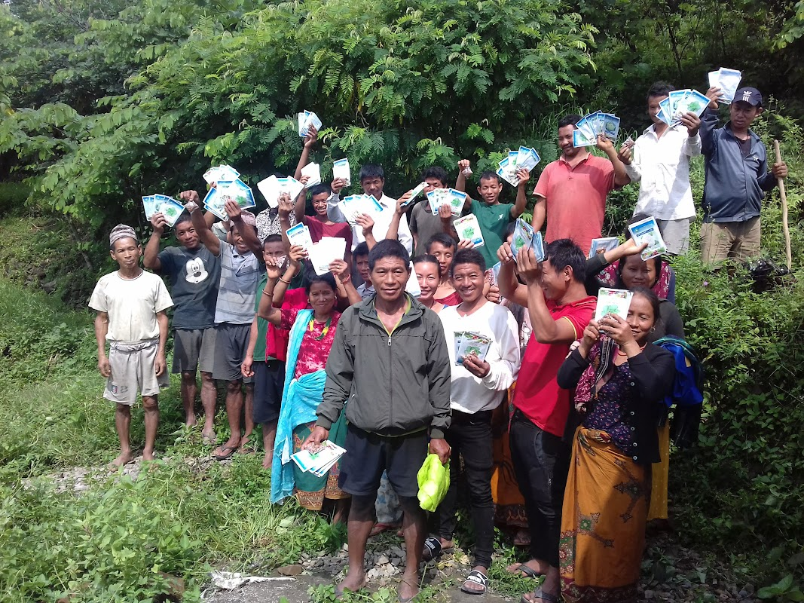

Annual Progress Report
(15 Sept 2021 – 14 Sept 2022)
Submitted to: Submitted by:
The Glacier Trust (TGT) Himalayan Community Development Forum (HICODEF), Nepal

Background
Himalayan Community Development Forum (HICODEF) has partnered with The Glacier Trust (TGT) in south-central Nepal to enable climate change adaptation in the remote mountain villages of the Siwalik range since 2009. HICODEF's work in this region has enabled people to increase their resilience to the growing impacts of various climate changes. From 15 Sept 2019 this project has been implemented by HICODEF in support of TGT and in close collaboration with farmers. The first phase of the project worked in three villages (Ripaha, Mathillo Baseni and Lahape) during 15 Sept 2019 to 14 Sept 2021. The second phase of the project in being implemented in adjoining villages of Dhoubadi, Pokhari, Dulunga and Charghare. These villages fall under two adjoining Rural Municipalities namely Hupsekot and Boundikali of Nawalparasi (east) district. The second phase of the project is being implementing during 15 Sept 2021 to 14 Sept 2024 as second phase. This is the first annual report of the second phase of the project.
Through this project we have reached further remote villages in the foothills of the Himalayas. This is an area of dangerously low food security. Climate change and inequality are exacerbating these problems significantly in this project. Coffee is being grown with other high value crops, root vegetables and fruits across the Himalayan foothills as a climate change adaptation and livelihood improvement strategy. Coffee is grown using the organic ‘layer farming’ method and is inter-cropped with fruits, vegetables and other high value crops to vastly improve income, diet and resilience to climate change. Through this project, we have tried to enable farmers to grow coffee commercially for the first time in the locality. There were a few coffee trees in the area planted years ago, the people did not know how to use of where to sell their products. Last year, a few of the farmers could sell their coffee beans they produced while the coffee trainer himself facilitated the sale. This is continued this year as well and the sale volume reached double, i.e. 152 KGs.
We know that most of the time of the 1st phase was spent in very critical situation due to the global pandemic of COVID-19. All the socio- economic condition of the people was adversely affected by the COVID -19 pandemic even in the rural setting due to lack of transportation and financial activities. Now the situation is getting better as most of the mobility of the people has been resumed. The communities have started to involve themselves in income generation activities, production, providing services. We have delivered the project activities smoothly while taking health and safety due to the pandemic seriously.
Most of the activities planned for the 1st year of 2nd phase have been completed. This report refers for the activities implemented in 1 year of the project (i.e. 15 Sept to 14 Sept, 2022) in the community of Dhoubadi, Pokhari, Dulunga, Baseni & Ripaha villages of Hupsekot Rural Municipality & Lahape village of Boudikali Rural Municipality.
This year the project activities were focused on the farmers' groups' formation, baseline survey, follow up meetings, onsite technical support, coffee cultivation trainings, coffee parchment preparation support, farming equipment support, coffee seedling plantation, school engagement program & coffee nursery management. As a result farmers' involvement in coffee seedling plantation for coffee cultivation is remarkably increased. Coffee seedlings are growing in project supported nurseries that will be planted next year.

Major activities done during this year
- Detail Baseline Survey
- Farmers Group formation
- Farmers Groups Meeting
- Training on Coffee cultivation, production & Harvesting
- Coffee seedling plantation and Nursery support
- Equipment Support for farming ( HDEP water storage Tank & Tunnel )
- Project Monitoring and evaluation
- Ground crops support (On-site technical support/ plant clinic)
- School engagement programme
- House formation
- Climate change class
- Coffee seedling plantation in school compound
- Litter picking and local environment care event.
- Facilitation for coffee parchment preparation and selling
- Monitoring & coaching of coffee seedling nurseries.
Implemented Activities and achievements of the year.
1. Details Baseline Survey
The baseline survey has been conducted in 4 sites Dhoubadi, Pokhari, and Dulunga of Hupsekot rural municipality and Charghare of Hupsekot Rural Municipality in Nov 2021. This is the regular process conducted in the beginning to set the milestone for the project and also to monitor the previous milestones. For conducting this survey we formed a farmer group in each site and conducted survey through Rapid Rural Appraisal (RRA) methods like household survey and focus group discussion, transect site walking to obtain information regarding agriculture production and productivity, cultivation and food sufficiency of the farmers. The survey covered 140 HHs of four groups.
According to baseline there are 140 HHs in 4 sites where there are 928 population (488 male and 440 female) out of which 15 HHs are headed by women. The status of food security are 18 HHs up to 3 months, 71 HHs up to 6 month, 37 HHs up to 9 month and only 14 HHs up to 12 or more. 3.51 hectares (68.95 Ropanies) of land is covered by vegetable, 134 HHs are involved in this vegetables cultivation for their domestic use. It is found that 17.86 hectares (351 Ropanies) of land is suitable for coffee plantation. There are 206 old coffee plants in these 4 sites. Similarly 1906 coffee seedlings are newly planted in these 4 sites. 44 persons gone for searching job outside the country.

The following tables details the findings of the baseline survey.
SN. | Name of Farmer Groups | HHs |  |  |  | women headed HHs | population
 |  | Dalit | Janajati | others | Total HH |  | F | M | total
1 | Rudragadi Farmer Group, Hupsekot RMP-5 Dhubadi Thanatole | 0 | 41 | 0 | 41 | 6 | 116 | 134 | 250
2 | Pokhari Farmer Group, Hupsekot RMp -5 Pokhari | 0 | 24 | 0 | 24 | 0 | 69 | 79 | 148
3 | Shuvabihani Farmers Group, Hupsekot RMP-4, Charghare | 1 | 47 | 0 | 48 | 8 | 149 | 172 | 321
4 | Ban Pipal Farmer Group, Hupsekot RMP -5 Dulunga | 0 | 27 | 0 | 27 | 1 | 106 | 103 | 209
Total |  | 1 | 139 | 0 | 140 | 15 | 440 | 488 | 928

Status of food security, vegetables & coffee
S.N. | Name of Farmer Groups | Food security Status (upto months/HHs) |  |  |  | Exiting coffee plants | Possible area for coffee plantation ( Ropani) | cultivated vegetable area |  | Migrated popln. For jobs. | Remarks New planted coffee seedling
 |  | 3 Month | 6 Month | 9 Month | 12 Month |  |  | area (Ropani) | Involved HHs
1 | Rudragadi Farmer Group, Hupsekot RMP-5 Dhubadi Thanatole | 5 | 23 | 9 | 4 | 133 | 116 | 12.95 | 41 | 15 | 1685
2 | Pokhari Farmer Group, Hupsekot RMp -5 Pokhari | 3 | 9 | 8 | 4 | 11 | 62 | 11.7 | 22 | 9 | 213
3 | Shuvabihani Farmers Group, Hupsekot RMP-4, Charghare | 10 | 17 | 16 | 5 | 54 | 136 | 14.3 | 46 | 5 | 0
4 | Ban Pipal Farmer Group, Hupsekot RMP -5 Dulunga | 0 | 22 | 4 | 1 | 8 | 37 | 30 | 25 | 15 | 8
Total |  | 18 | 71 | 37 | 14 | 206 | 351  (17.86 hectares) | 68.95  (3.51 hectares) | 134 | 44 | 1906
Note: (1 hectare= 19.65 Ropanies)

2. Farmers Group formation
During this period four groups of farmers interested in coffee farming have been formed in Dhoubadi, Pokhari, Dulunga and Charghare villages. The Detail of Farmers groups are as follow.
 | Name of Farmer Groups | HHs |  |  |  | women headed HHs | population
 |  | Dalit | Janajati | others | Total HH |  | F | M | total
1 | Rudragadi Farmer Group, Hupsekot RMP-5 Dhubadi Thanatole | 0 | 41 | 0 | 41 | 6 | 116 | 134 | 250
2 | Pokhari Farmer Group, Hupsekot RMp -5 Pokhari | 0 | 24 | 0 | 24 | 0 | 69 | 79 | 148
3 | Shuvabihani Farmers Group, Hupsekot RMP-4, Charghare | 1 | 47 | 0 | 48 | 8 | 149 | 172 | 321
4 | Ban Pipal Farmer Group, Hupsekot RMP-5 Dulunga | 0 | 27 | 0 | 27 | 1 | 106 | 103 | 197
Total |  | 1 | 139 | 0 | 140 | 15 | 440 | 488 | 928

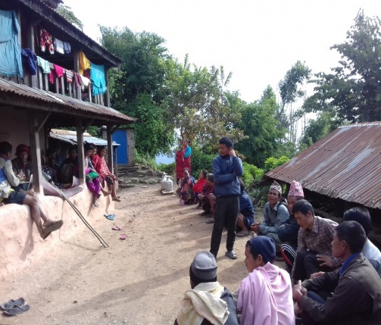
In the meantime, inception workshops have been conducted in each site to inform them about the project objective, expected results including planned activities, budget and their (farmers') roles and responsibilities. After formation these groups have registered in respective rural municipality. All activities of the project have been implemented in consultation with these groups.

Photo: Farmers group formation meeting in Charghare

3. Farmers groups Meeting
Farmer groups meetings & follow-up is a continuous activity of the project. We sit together, discuss & decide with farmers on newly implementing activities before its implementation in the project site. We also review & go through the implemented or conducted activities in these meetings. During this year we conducted 14 meeting of farmers groups where we discussed & decided about the training of coffee farming & cultivation, date, venue, participation and selection of farmers for tunnel farming & HDPE tank distribution, coffee cherry picking, pulping, parchment preparation, marketing and selling, maintaining shade crops, cultivation of ground crops, coffee seedlings weeding etc. As a result of the meetings, we were able to conduct coffee cultivation training on time, farmers are picking & pulping coffee cherry, made parchment & sold on time. Farmers are selected for tunnel farming & HDPE Tank distribution. Newly planted coffee saplings are properly cared for, watered and fertilized, shade maintained and weeding done on time.

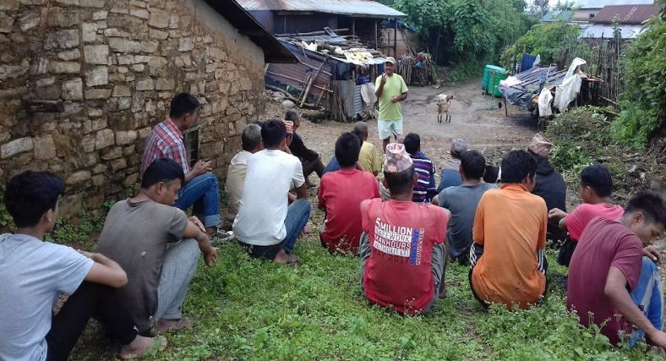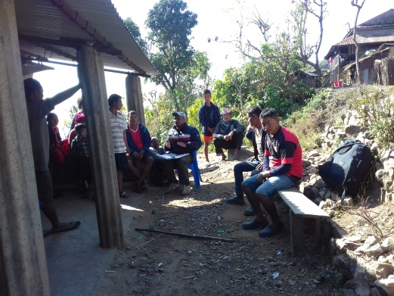
Farmers groups Meetings in Pokhari and Charghare
4. Training on Coffee cultivation, production & Harvesting
We organized 4 events of coffee cultivation & production training in Dhoubadi, Charghare, Pokhari & Dulunga as per the annual plan. Two days' training were separately organized in the each of the four sites of the project area. Mr. Mitha Ram Jamakatel was the main facilitator of these trainings. He is a grassroots level (farmer's level) trainer of coffee farming who himself is a coffee production farmer from Lalitpur district.
History of coffee cultivation, varieties of coffee & its nature, environmental aspects, & location for coffee farming, coffee nursery & plantation, garden management, coffee pest, pesticides & diseases, coffee harvesting, coffee bean processing technique & its marketing were the major contents of the training.
The training was conducted through lecture, presentation, practical exercise methods on the existing/yielding coffee plants in the village. A total of 110 (50 F. 60 M.) farmers participated in the four sites of the trainings. Among them 1 persons belongs from Dalit ethnicity and the rest 109 persons were Janajati. The participants were very much excited for the training as they saw coffee yield and market opportunity. After the training all the participants committed to plant some coffee plants in their field next season. At end of training a coffee seedling nursery (Approximately 3000 seedling capacity) has been established in each site of training.

The table below details the numbers of participants in each training site.
Training conducted Date | Training Site | No. of Participant
 |  | Total | Female | Male
10-11 Mar, 2022 | Dhoubadi | 28 | 15 | 13
13-14 Mar, 2022 | Charghare | 36 | 15 | 21
16-17 Mar, 2022 | Pokhari | 19 | 7 | 12
19-20 Mar, 2022 | Dulunga | 27 | 13 | 14
Total |  | 110 | 50 | 60

- Coffee cultivation Training at a Glance (Dhoubadi)
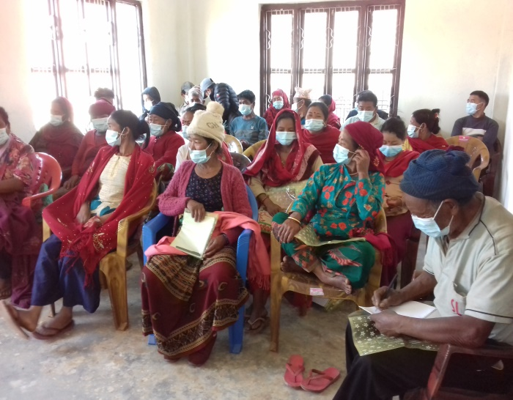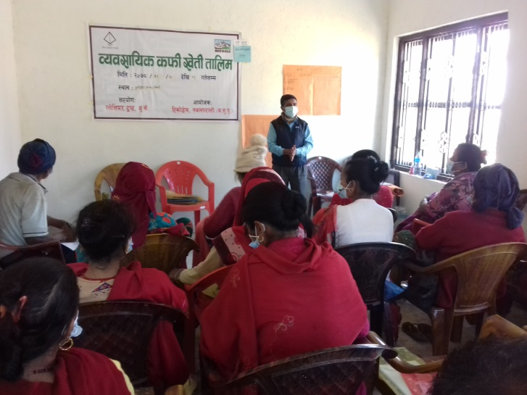
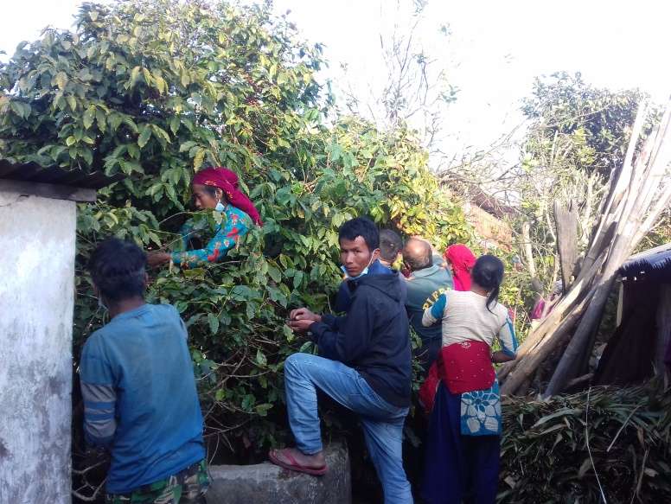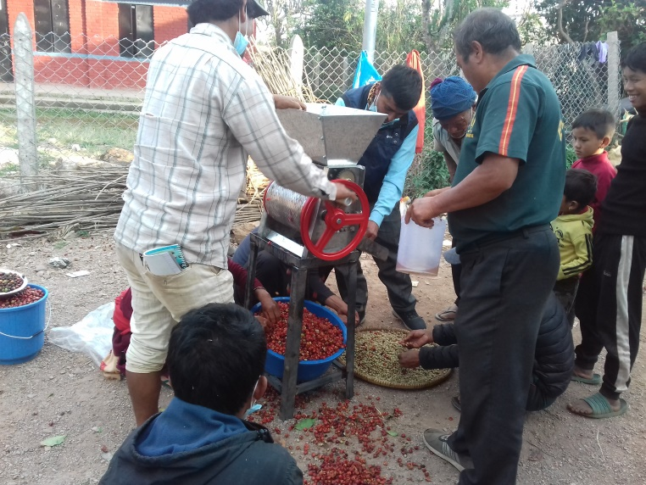

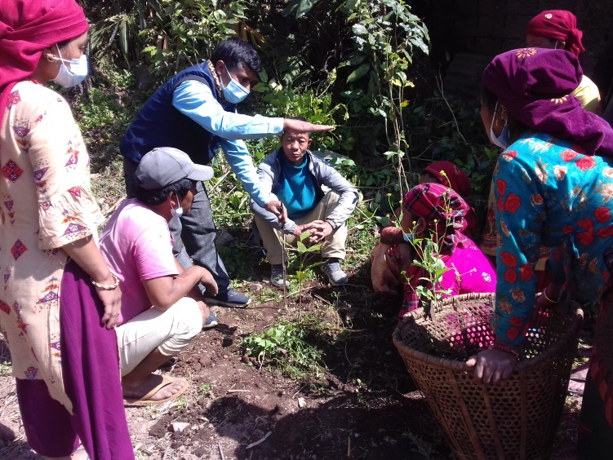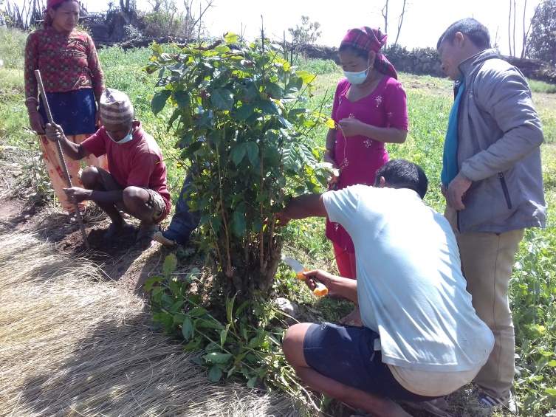
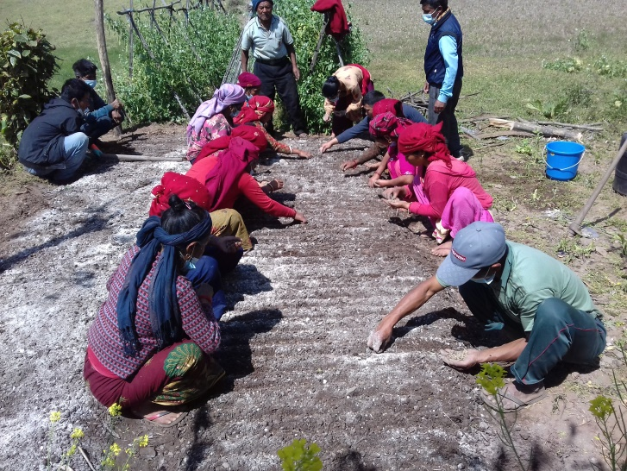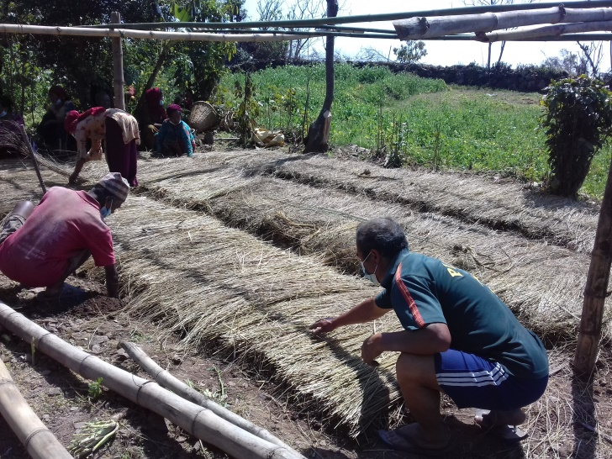
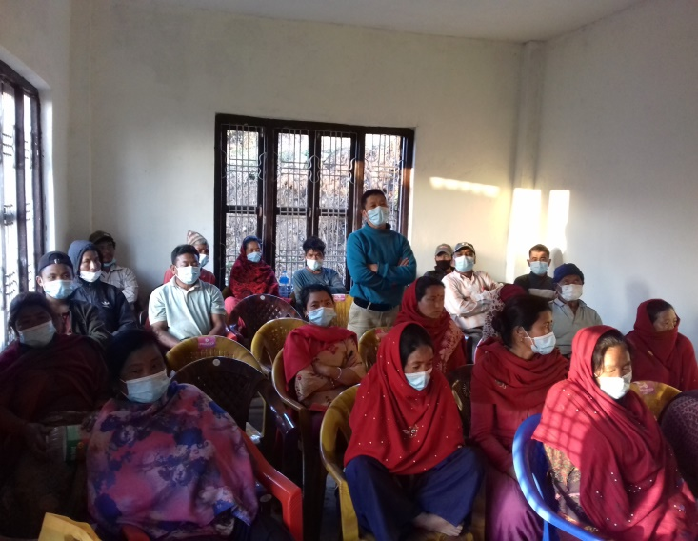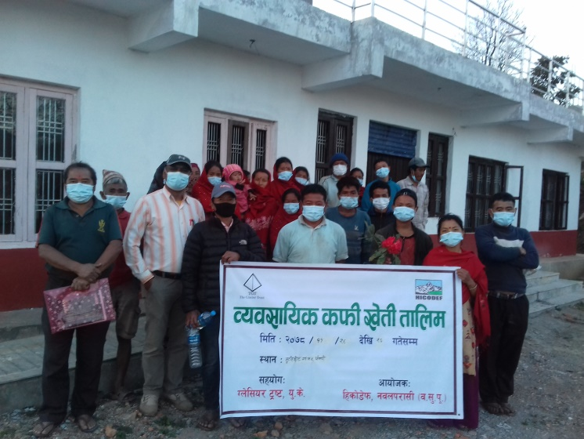

- Coffee Training at Charghare village
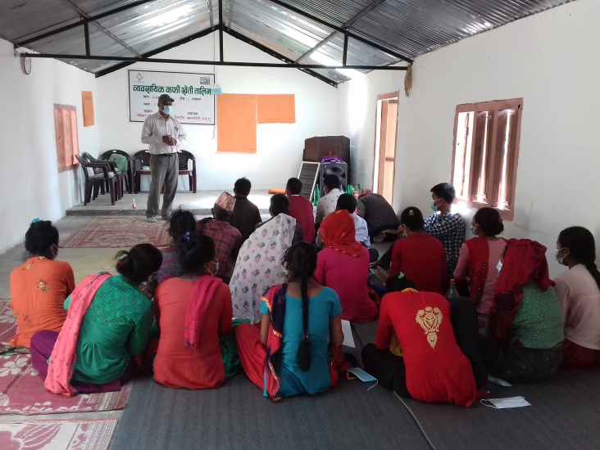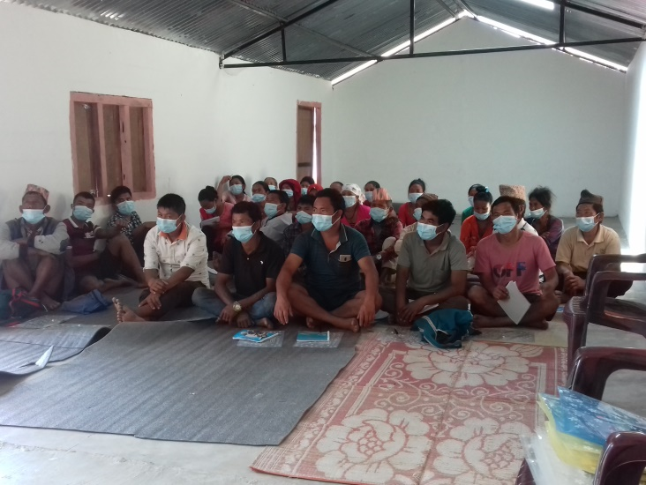
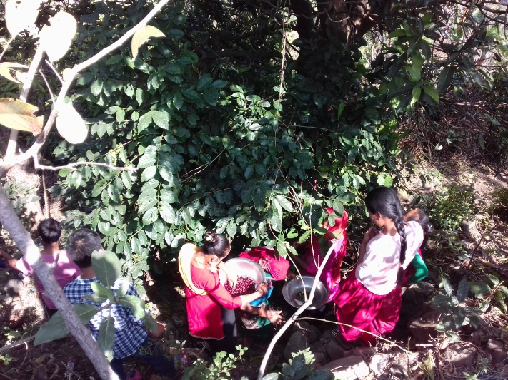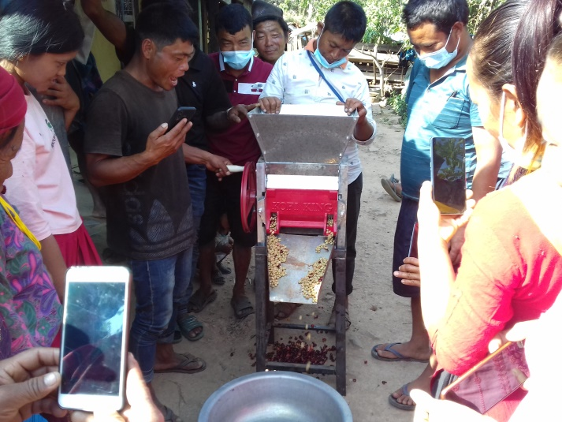
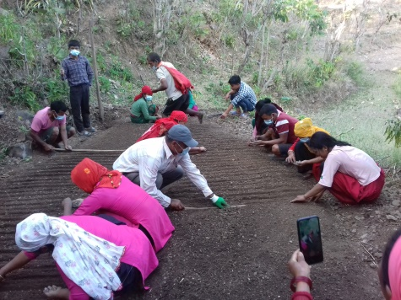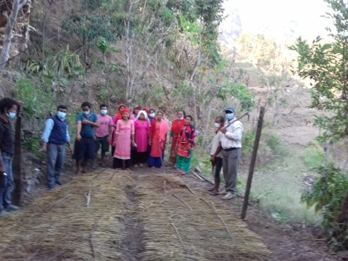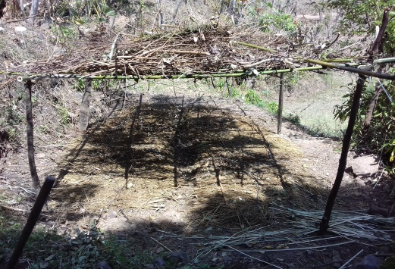
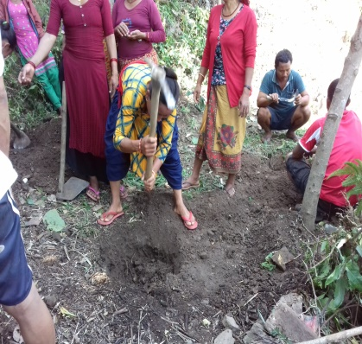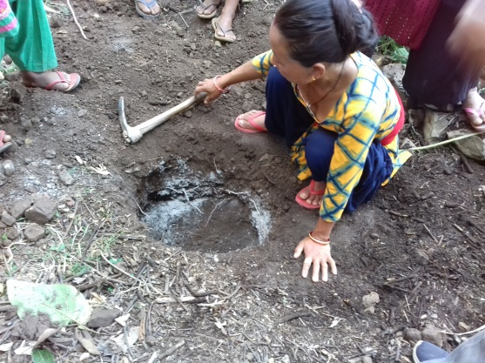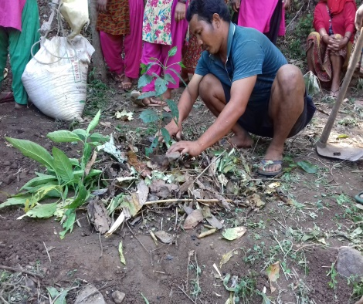
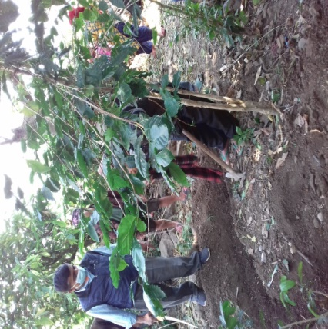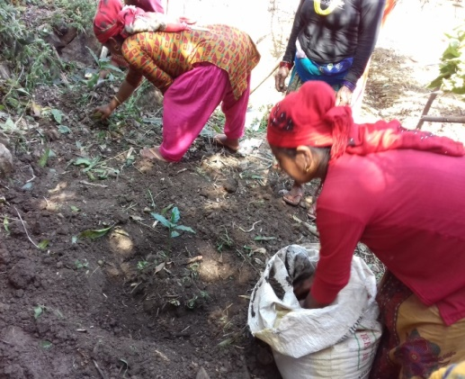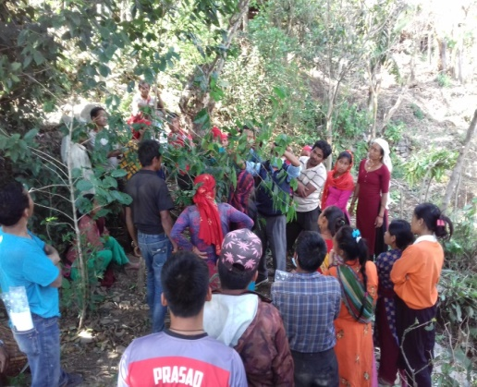
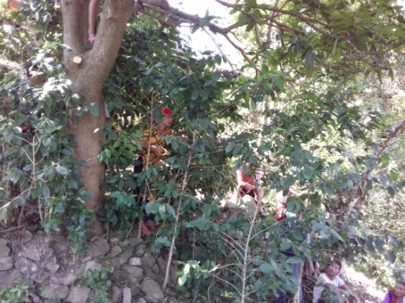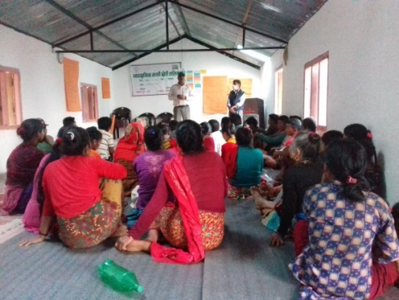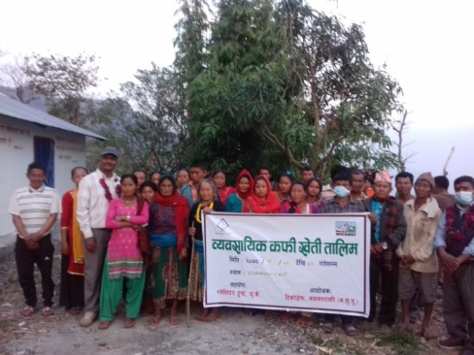

- Coffee Training at Pokhari
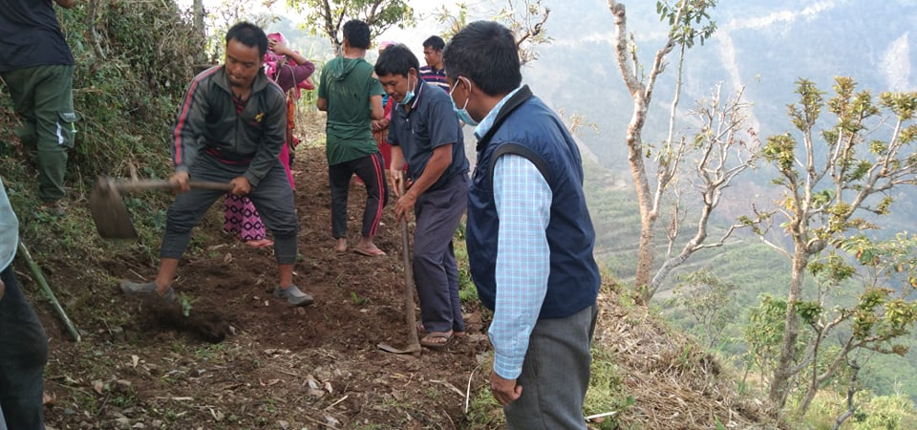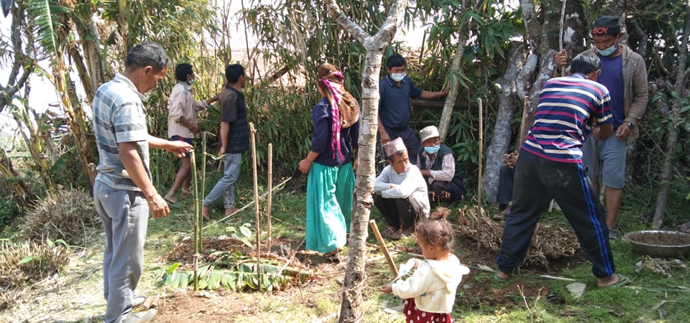
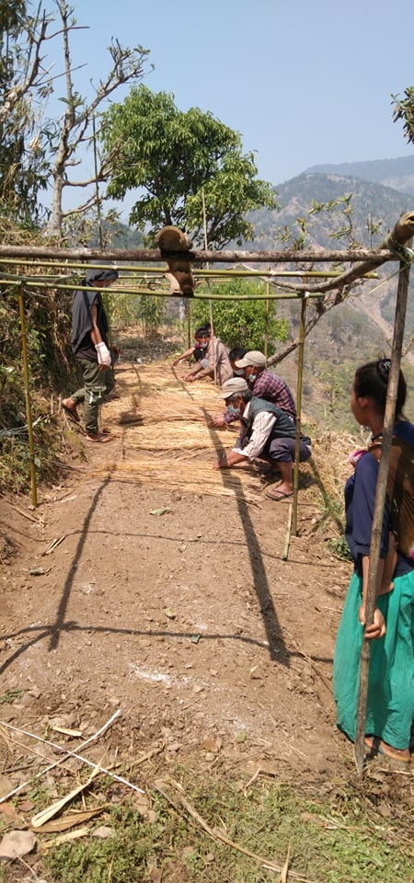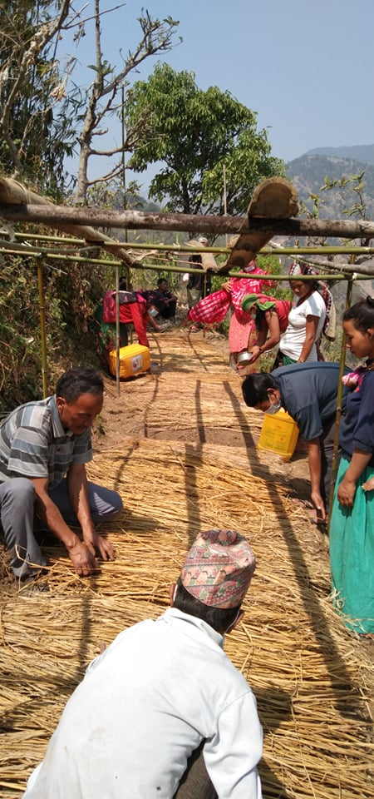

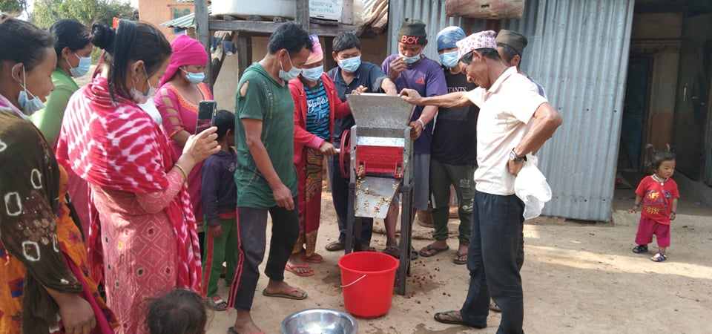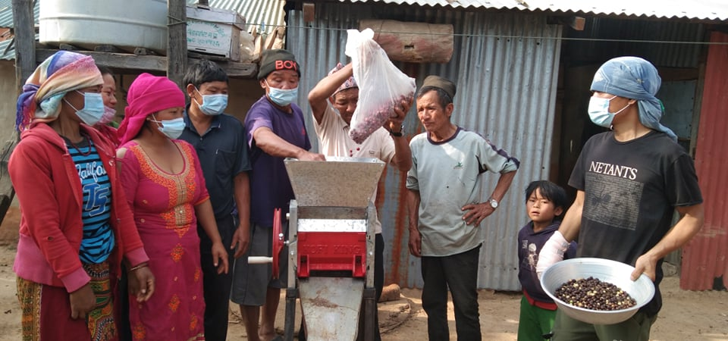
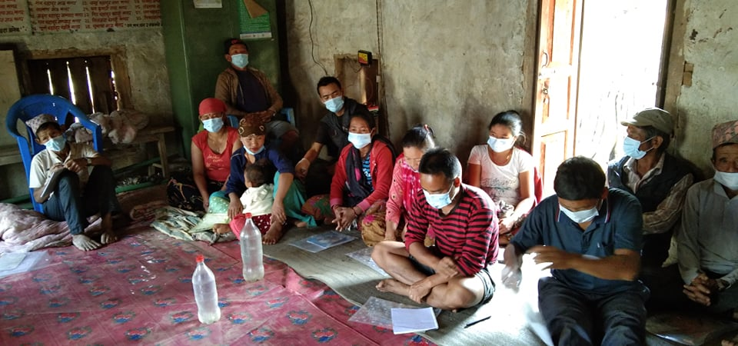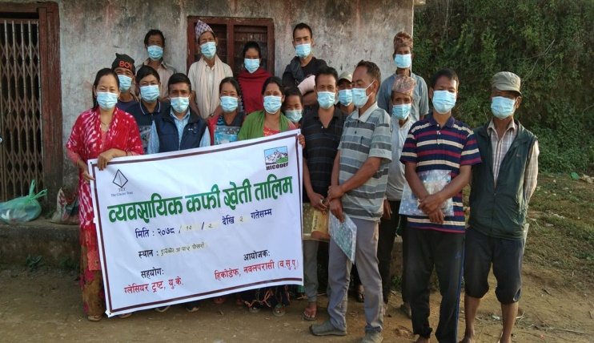
- Coffee Training at Dulunga
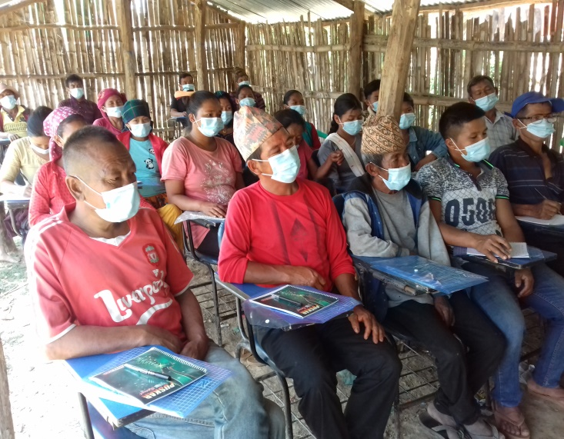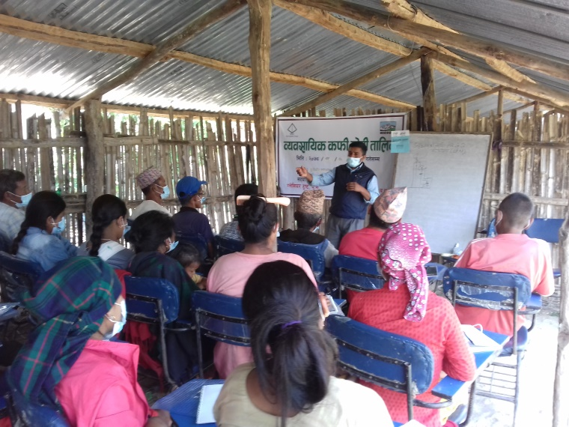
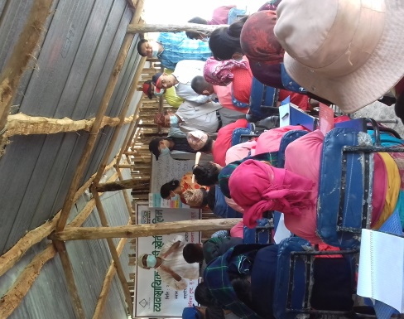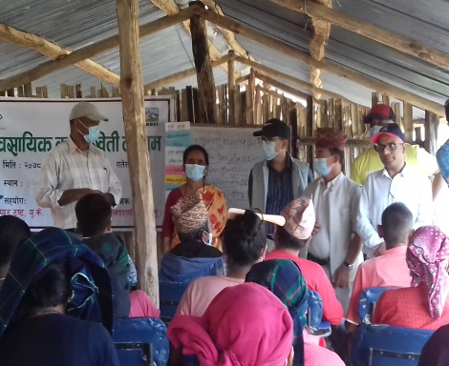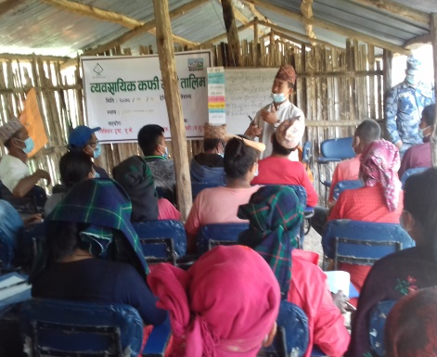
Coffee Training was monitored By CDO, DCC chair person, Rural Municipality Chairperson at Dulunga
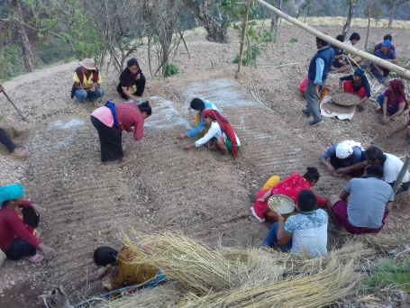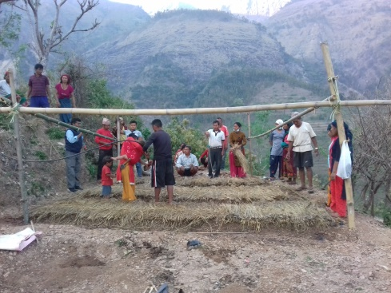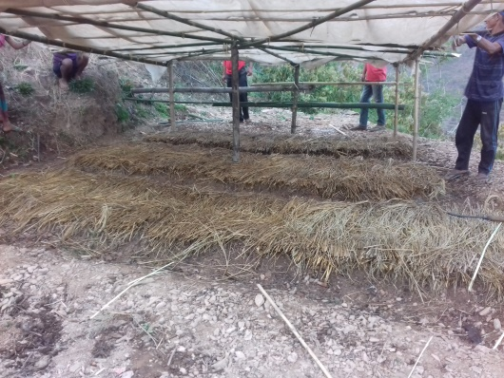
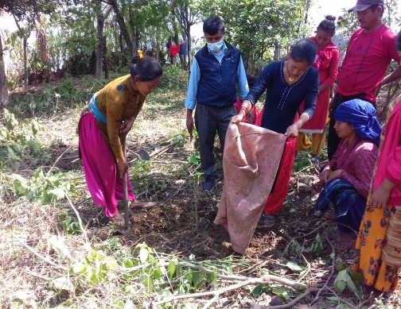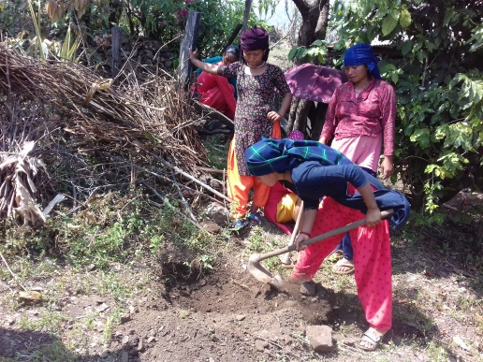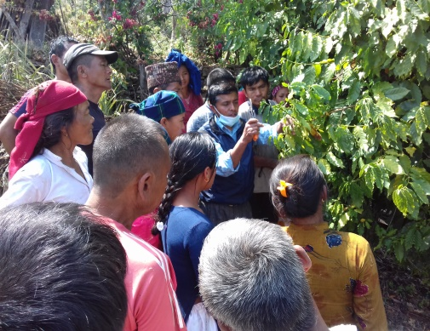
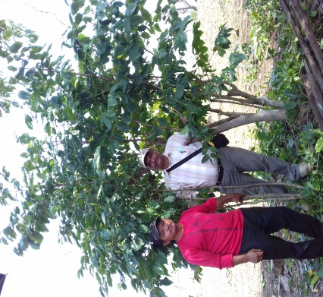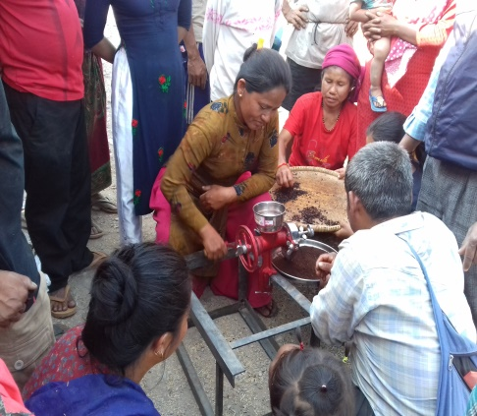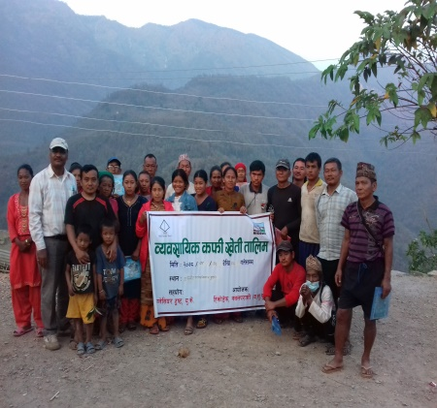
5. Coffee seedling plantation and nursery support
Coffee seedling support & plantation is another major activity of the project. During this period we have conducted two types of coffee plantation in the community. First, farmers HH level coffee plantation; and second, Coffee plantation in School area by mobilizing students. A total of 138 HHs Farmers (136 Janajati 2 Dalit) of 7 farmers' groups have been involved and planted 5877 coffee seedlings this year. They managed 1757 seedling among themselves by local nursery and 4120 were seedling supported by the project. The coffee seedlings managed by project were brought from Dhading District. As per their interest and available space, the farmers have planted 20 to 260 coffee seedlings individually. Most of the coffee seedling has been planted with maize and some are with fruits and fodder plants that will maintain layer farming and intercropping system. Similarly, the students of Shiksha Bodhani secondary school of Hupsekot -5, have planted 112 coffee seedlings in the school compound. The detail of coffee plantation is given in table.
Project site | No of HHS in involved coffee Plantation | self-managed coffee seedling | Project supported seedling | Total (till 30 June 2022)
Dhoubadi | 34 | 150 | 1220  (including schools') | 1370
Pokhari | 20 | 22 | 650 | 672
Charghare | 35 | 48 | 1370 | 1418
Dulunga | 28 | 35 | 880 | 915
Lahape | 4 | 210 | 0 | 210
Baseni | 6 | 510 | 0 | 510
Ripaha | 11 | 782 | 0 | 782
Total | 138 | 1757 | 4120 | 5877

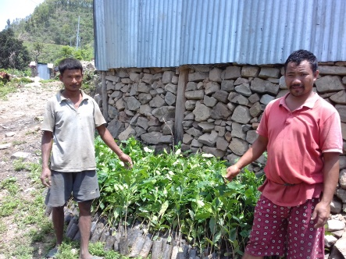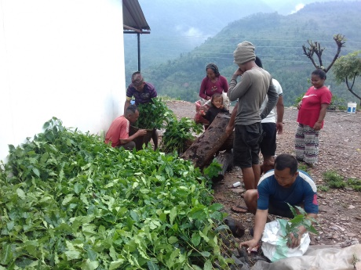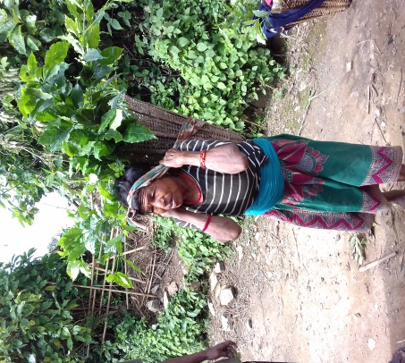
Coffee seedling Support & Distribution
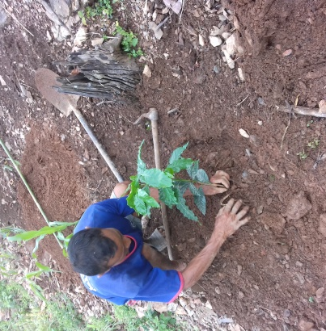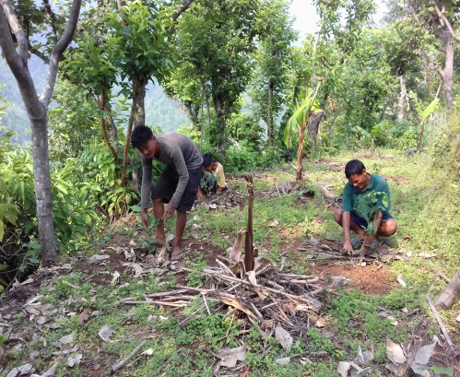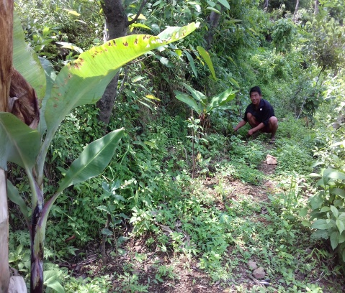

Coffee seedling Plantation

6. Equipment Support for farming (HDEP water storage tank & tunnel)
This year we have supported 16 No of 1000 Liters HDP Tank for irrigation & 16 No. of Silpaulin sheets (10M*6M) for tunnel making. Four farmers of Hupsekot- 4 Charghare, 4 farmers of Hupsekot 5 Dhubadi, 4 farmers of Pokhari & 4 farmers of Dulunga have received these tank & tunnel support as agreed in the farmers meeting.
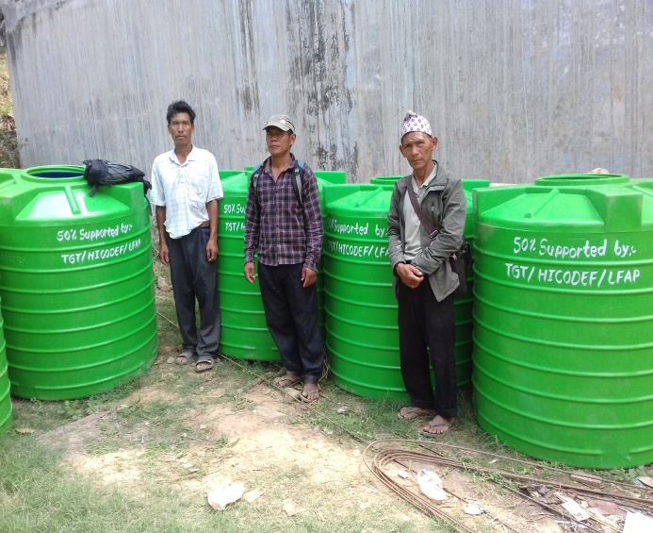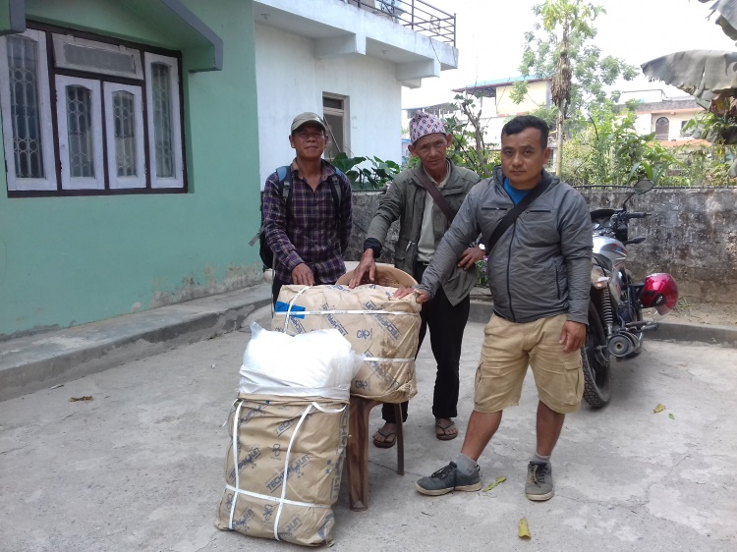
IrrigationTanks & silpouline for tunnel receiving by pokhari farmers
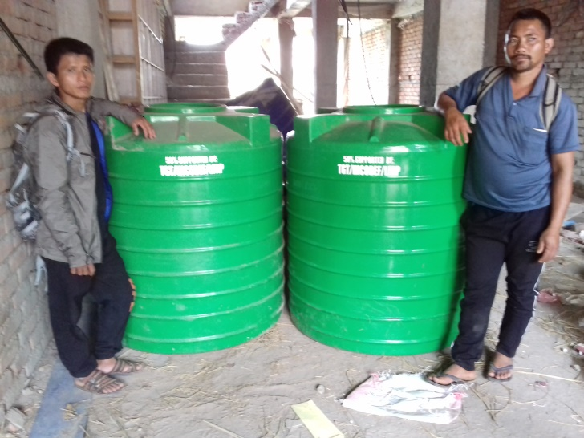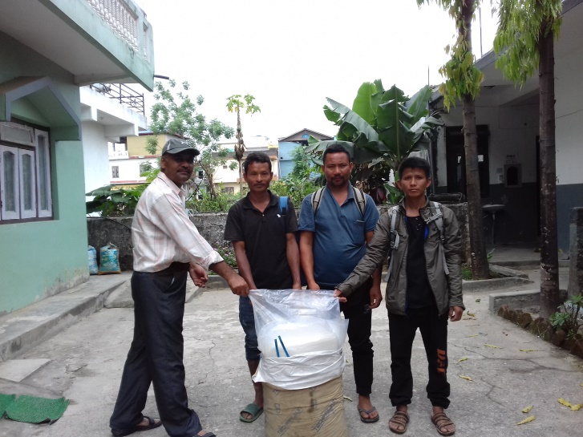
Irrigation Tanks & Silpouline for tunnel making are reciving by Farmers of Charghare
In this activity 50% amount of total cost & transportation is contributed by the concerned beneficiary farmers in HDP tank and all the tunnel making cost is borne by the famers. This creates their ownership as they invest their money. After getting the support for Silpaulin & HDP Tank, the farmers have fixed the tank and started to make the tunnel in their fields. The objective of this activity is to support to increase the agriculture product especially vegetables and coffee ensuring peoples participation. The farmers are very encouraged to cultivate vegetables in tunnel by this support, they have seen the difference in our previous efforts.

7. Project Monitoring & Evaluation visit
A Six days (6-11 Dec 2021) monitoring visit was conducted in the participation of HICODEF team (ED and PC) and Co-Director (Nepal) of TGT in 5 project sites viz. Ripaha, Pokhari, Charghare, Dhoubadi and Lahape. There were two major objectives of this visit. A, to monitor & evaluate the 1st phase project progress and B, to find the current status of 2nd phase project site. The monitoring team visited Ripaha & Lahape for assessing the project progress. Likewise the team visited Pokhari, Charghare & Dhoubadi to meet the objective B. During this field trip the team visited & observed coffee planted sites and nursery area. During the visit the monitoring team have made an interaction with communities in each sites. In the interaction HICODEF ED shared the project objectives, working area, activities components, implementing methods, process & its expected outcome of the project. In Lahape the team visited school which was engaged in the program first phase and also observed few of the practical exercise sites and coffee farms. The Team made contact with the school management team and teachers, and got feedback and suggestions from the communities & teachers for further project activities. HICODEF ED gave some suggestions regarding the expectation of community at the end of community interaction in each visited site. The visit has given us clarity and simplified the working process for the implementation of project activities. Below are few photos of the trip.

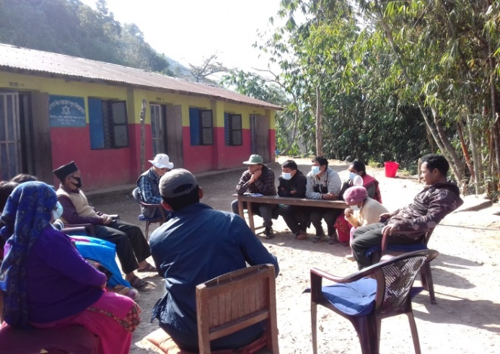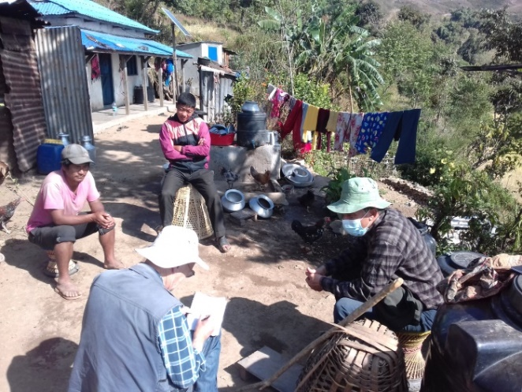
Meeting with school Management Community in Lahape & community discussion in Dhoubadi
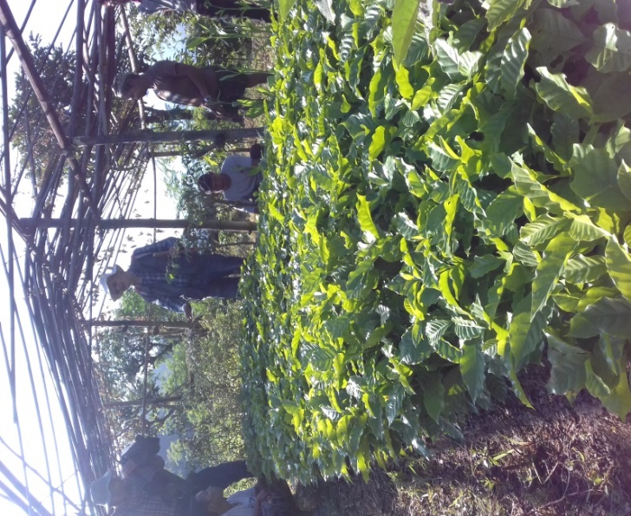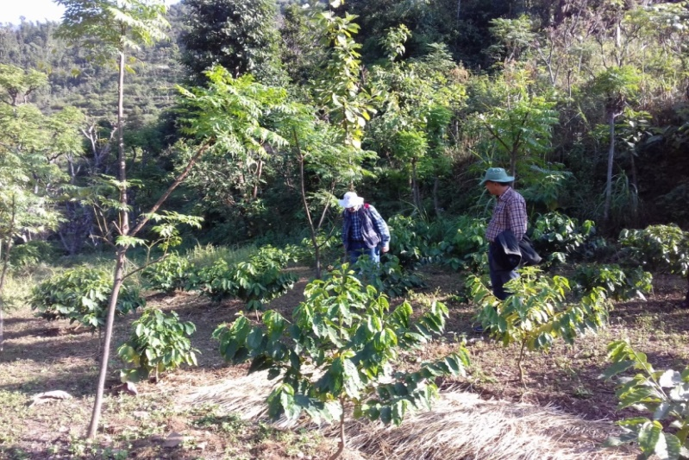
Coffee Nursery & coffee pantation site observation in Ripaha
8. Ground crop support (On Site Technical Support and Plant Clinic).
Ground-crop seed support & onsite technical support/plant clinic is another activity of this project. Through these activities the project supported farmers to grow ground crops like ginger, turmeric and a variety of vegetables along with shade crops. The project is organised onsite technical supported classes and plant clinic workshops in each village to enable farmers to develop the skills needed to grow and nurture ground crops and vegetables. In these classes we also discussed on effective water management techniques, organic fertiliser and organic insect pest control methods
This year we have supported 2 sessions on-site technical support in Ripaha & Lahape. In these sessions, we discussed on agriculture problems faced by them, diseases of vegetables plants, practically exercised tomato seedling transplantation bed (Dyang) in tunnel & suggested possible solution of treatment in farmers' group. At the same time they have been taught about the preparation of organic manure & bio-pesticide for organic farming. There were 41 farmers (15 F & 26 M) participating in the class & exercise. After the on-site classes, it was found that more than half of the participating farmers continued to make bio-pesticide and collect cattle urine for liquid organic manure for their vegetable cultivation.
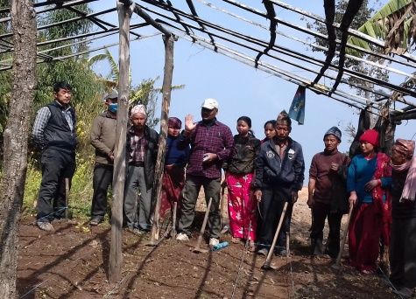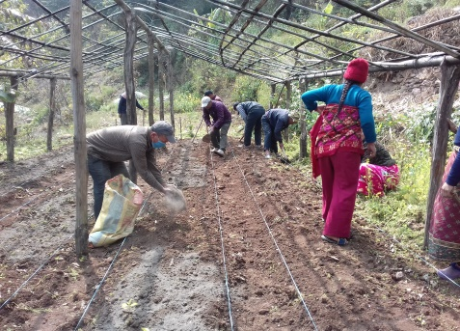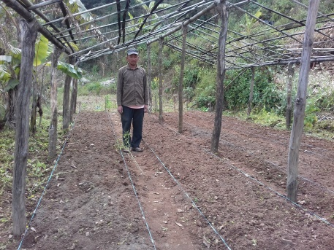
Onsite technical class of preperation of tomato seedling transplant bed in the tunnel.
In this period we have conduced 5 sessions, one each on-site technical support/classes in Dhoubadi, Pokhari, Charghare, Dulunga & Baseni. In these sessions we discussed coffee seedling plantation & weeding, fertilizing, making bio pest, organic & liquid fertilizer. In this session the farmers' were involved in practical exercises for seedling transplantation, weeding, fertilizing & treatment of coffee seedlings; they were advised on possible solution of treatment by bio pesticide. There were 146 (144 Magar & 2 Dalit) farmers (45 F & 101 M) participated in the class & exercise. After the classes, 104 farmers Households have started to plant the coffee seedling in their fields. Made commitment to make & use bio-pesticide and collect cattle urine as liquid organic manure for their vegetable & coffee farming.

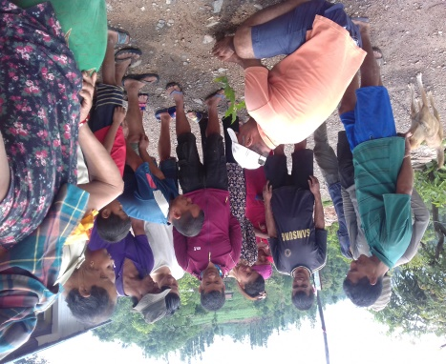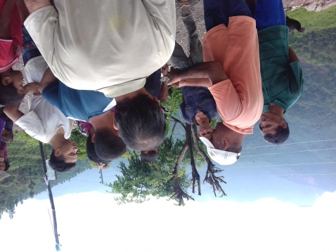
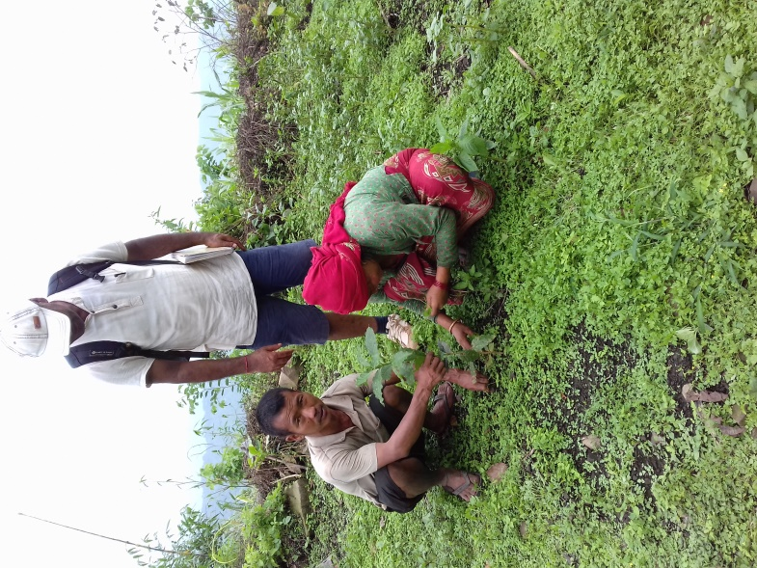
Coffee seedling plantation onsite classes
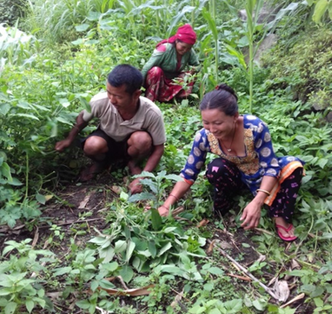
Coffee weeding under technical supervision
We organized technical sessions in all the 4 sites (Dhoubadi, Pokhari, Charghare & Dulunga) for the preparation of seedling & transplant of winter vegetable. The session focused on preparation of nursery bed, seed sowing, watering, caring and transplant of seedling. After the session, improved seeds of radish, cauliflower, cabbage, green bean and green mustard have been distributed to all the farmers of 4 sites. In total we distributed 15.86 kg improved seeds to 130 HHs farmers of the 4 site. After the seed received, most farmers prepared nursery bed individually and started to transplant seedlings in their coffee farm & kitchen garden. Due to the constant monsoon, some seedling nurseries are damaged & seedling transplant have been delayed.
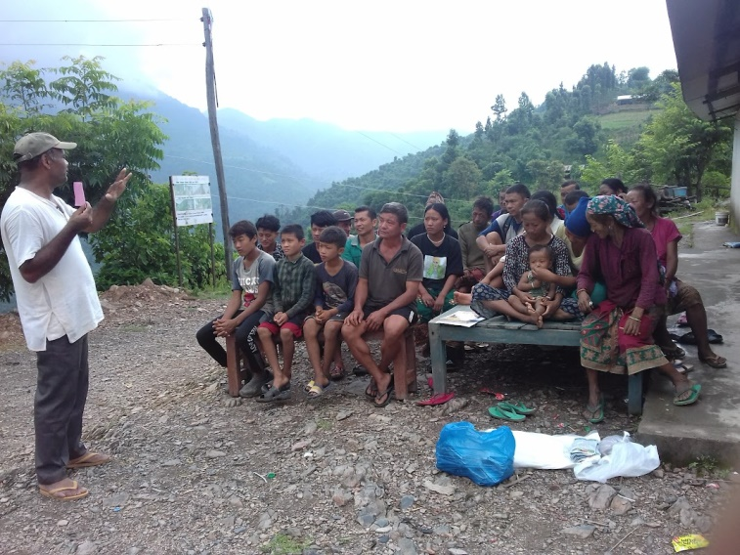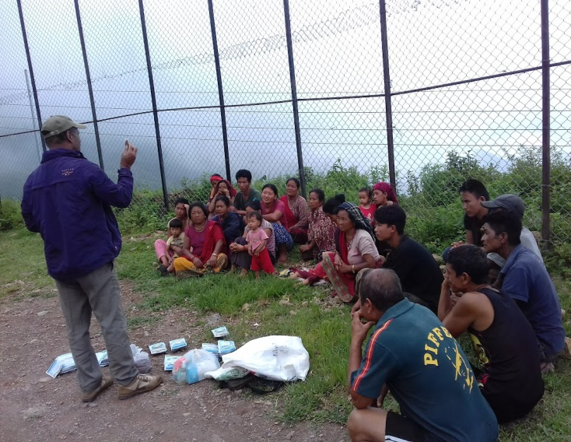
Technical class for vegetable seedling preparation
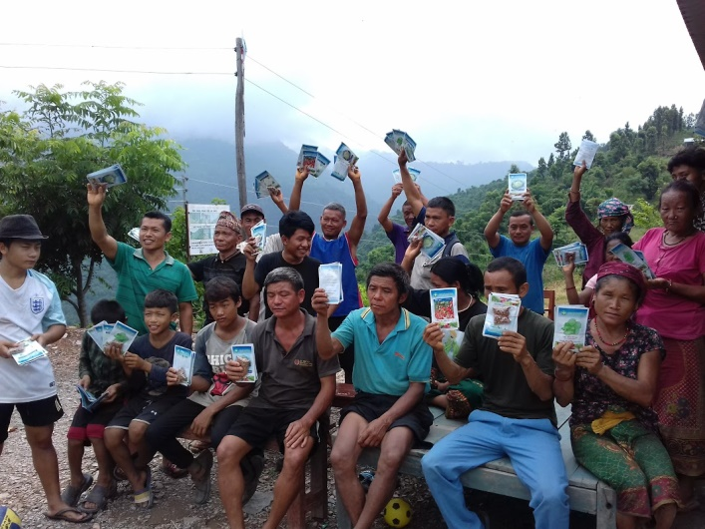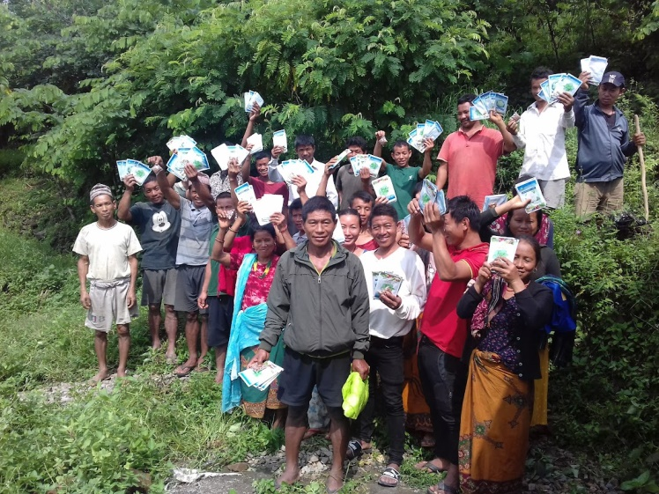
Vegetable seed distribution

9. School engagement program
During this year we have conducted school engagement program in the project sites. As school engagement program we conducted 4 types of activities (House groups formation, Climate change class, Coffee seedling plantation in school compound & litter picking in schools compound & nearby village) in 2 schools of project sites (Dhoubadi, & Charghare).
- House groups formation
As per the project plan, school engagement program is done in the 2 schools of the project sites namely Dhoubadi, & Charghare) during this period. There are 1-10 grades in Dhoubadi (Shiksha Bodhani secondary School, Hupsekot 5, Dhoubadi), 1-5 grades in Charghare (Bal Jagaran Primary school, Hupsekot 4 Charghare). The whole students of both the schools were split into 4 houses (groups) Red, Yellow, Blue & Green for their identity. Each group has selected a Group Leader from among the member students. Each groups is mentored & facilitated by a house teacher. This was the initial activity of the school engagement program. All the school engagement activities is done by these groups in school. Every activity is considered as a competition among the houses. During this period we have also provided some essential tools & equipment for the planned activities to come. 90 students (38 F & 52 M) & 16 teachers (9 F & 7 M) are directly engaged/benefited in the program. All the students of schools are very excited & interested in these extra-curricular activities and have learnt as they work.
The table below shows the details of beneficiaries in the schools:
SN. | Name of School | Participation
 |  | Students |  |  | Teachers |  |  | Total
 |  | F | M | T | F | M | T | F | M | T
1. | Shree Shiksha Bodhani Secondary school, Hupsekot 5 Dhoubadi | 26 | 40 | 66 | 6 | 6 | 12 | 32 | 46 | 78
2. | Shree Bal Jagaran primary school, Hupsekot 4, Chargare | 12 | 12 | 24 | 3 | 1 | 4 | 15 | 13 | 28
Total |  | 38 | 52 | 90 | 9 | 7 | 16 | 47 | 59 | 106

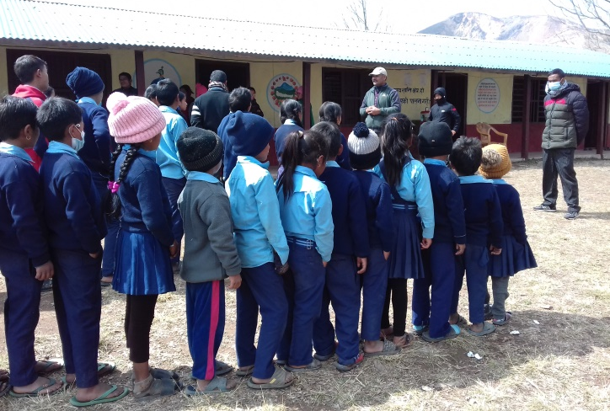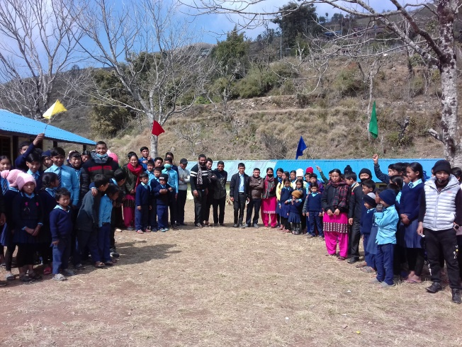
School program in Dhoubadi
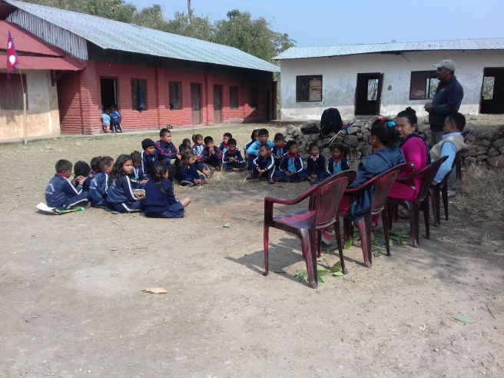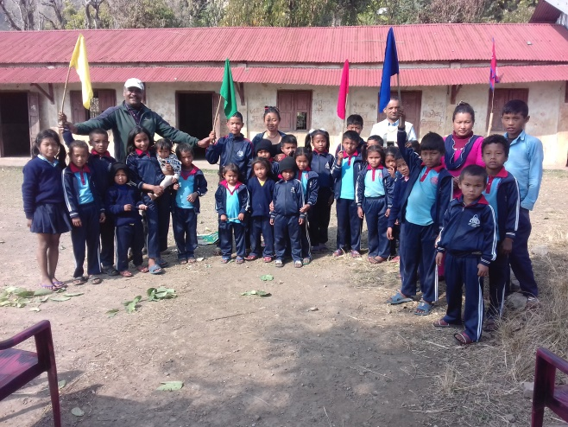
School program in Charghare
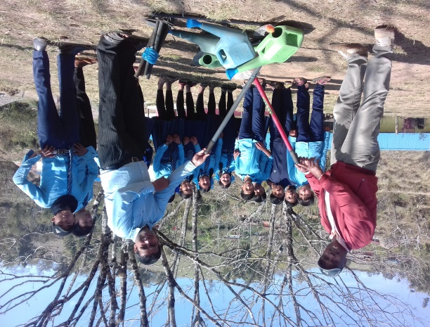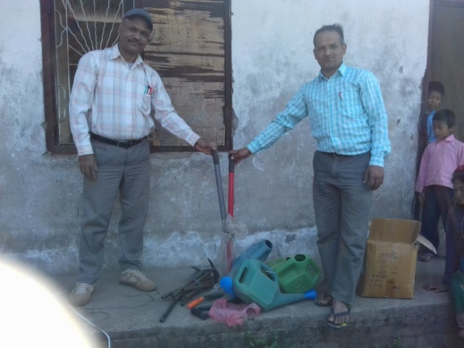
Essential equipment/tools handover to school for program conduction

- Climate Change Class
There are 1-10 grades in Dhoubadi (Shiksha Bodhani secondary School, Hupsekot 5, (Dhoubadi), 1-5 grades in Charghare (Bal Jagaran Primary School, Hupsekot 4 Charghare). During this period we have conducted one day climate change class in both the schools. In the classes we discussed what is climate change, its Impact, & addressing measure (i.e. the local incentives). All the classes are delivered using teachings materials like flip chart, presentation and Groups discussion Methods. The students give more interest/attention in such classes and presentation. 90 students (38 F & 52 M) & 16 teachers (9 F & 7 M) are directly benefited from this program. After the class they have prepared action plan for the regular sanitation of school and small local environmental management.
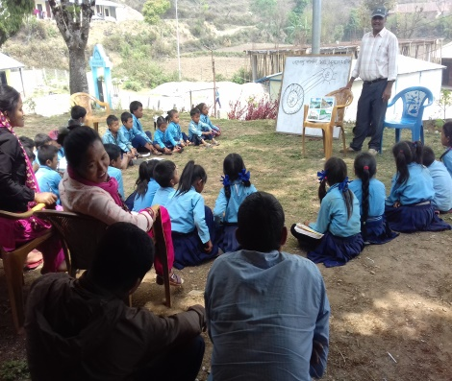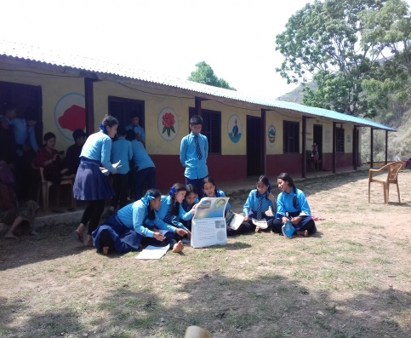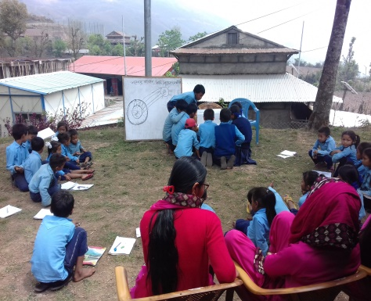
Participation of Students & teacher in CC Class

- Coffee seedling plantation in School compound
During this period we facilitated coffee seedling plantation in the school area of Shiksha Bodhani secondary School Dhoubadi in coordination with school teachers & management committee. This gave students practical skills in coffee plantation as an extra-curricular activity which is happening in their village. Considering this fact, teachers & parents agreed to conduct one event coffee plantation around the school premises mobilizing the students. All the students from class 2-10, some parents and teachers actively took part in the event. The school has been planted 112 coffee seedlings in school's enclosed compound by this program and most of the plants have survived.
Before starting field activities, we facilitated students how to dig pits, filling of pits, line to line distancing, plant to plant distancing, plantation, watering & fertilizing technique for proper coffee plantation. To promote the sense of competition among the students themselves, all the activities are done in house groups. The best performing house will be awarded later. We divided the available land in the school into four plots and assigned one part for a house. The entire students have actively participated in these activities and are very keen and excited for achieving the better result as we have announced to reward the best performing house. It is expected that they will not only take proper care of the plants but also motivate other students for caring of their plants and take this message back to their families.
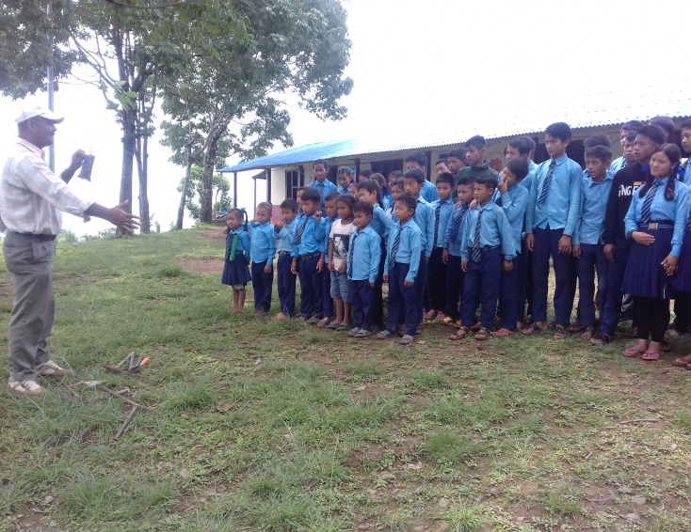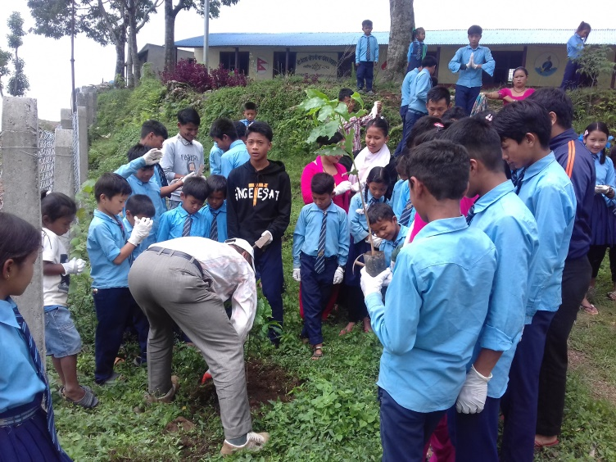Facilitation coffee seedling plantation technique to the the schoolchildren.

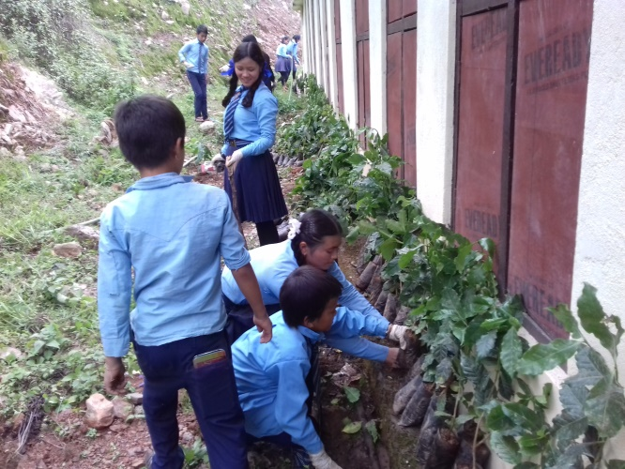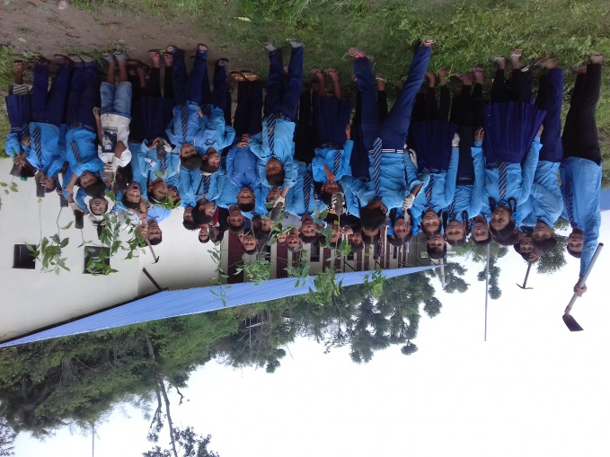

Student preparing for coffee plantation in school compound

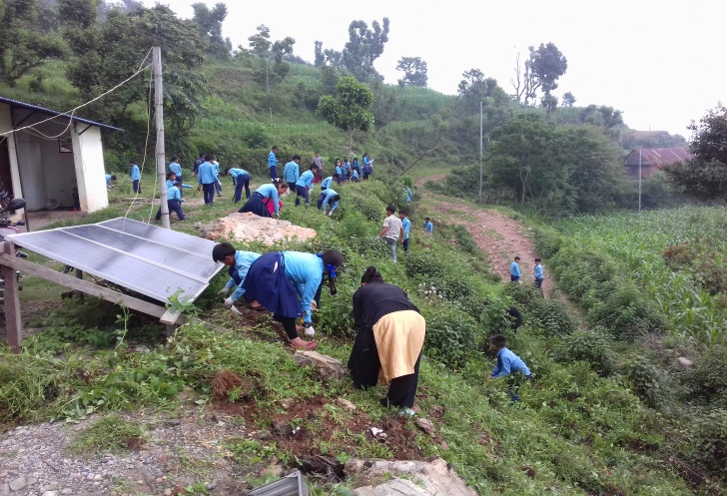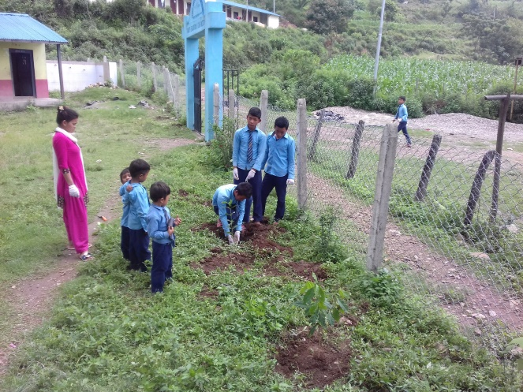Site cleaning & coffee plantation

- Litter picking and local environment care event
During this period we have conducted one day litter picking local environment care event in schools of Dhoubadi & Charghare. To conduct this activity, project team coordinated school teachers & management committee of both schools for involving the students in litter picking and local environment care event as an extra-curricular activity. Considering this fact teachers & parents agreed to conduct one event around the school premises taking health rules precautions. All students from class 2-10, some parents and teachers actively participated in the event. All the non-decomposed litters, plastics of school compound and nearby village way have been picked & collected by the students during this event and made the school compound and surrounding area clean. This event has given a message to the community to conduct such type of event in certain week's intervals. This will not only clean the area periodically but also control the disposal of litter in assigned area and keep the area clean.
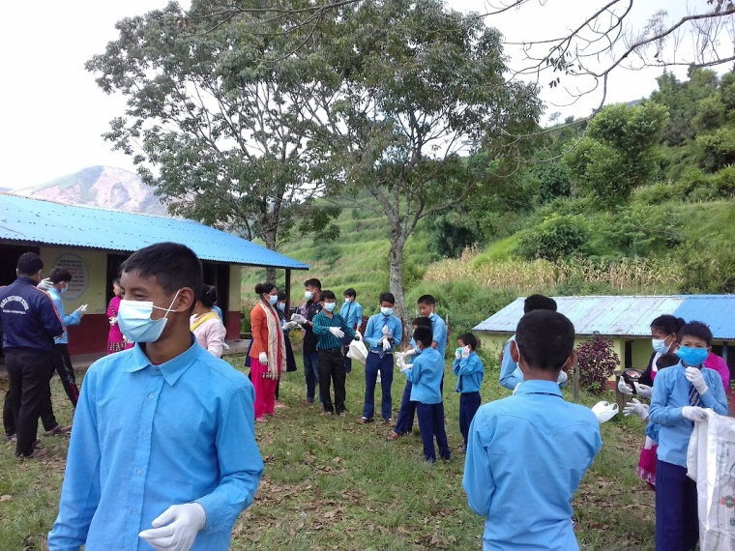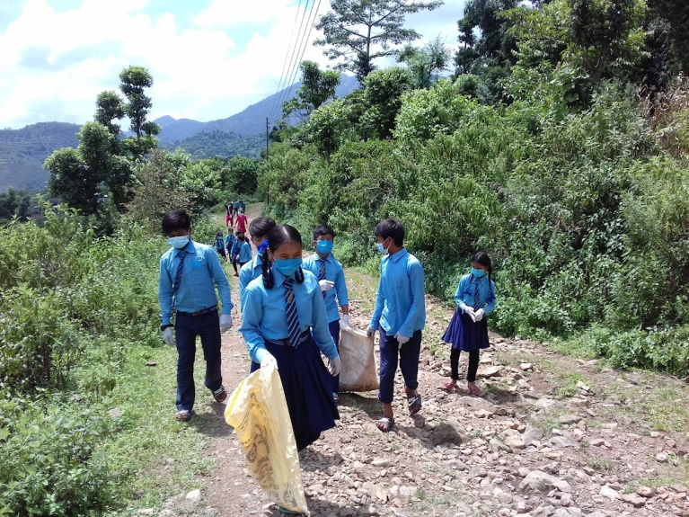
Litter picking event of Dhoubadi
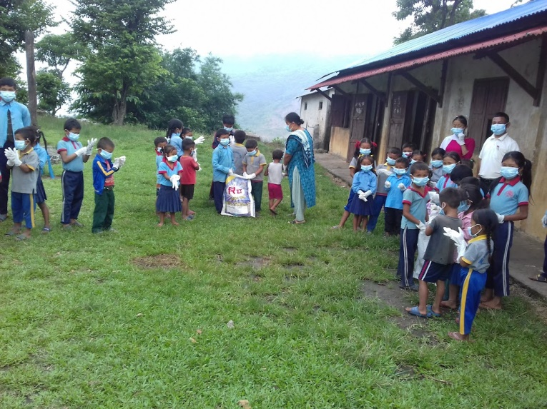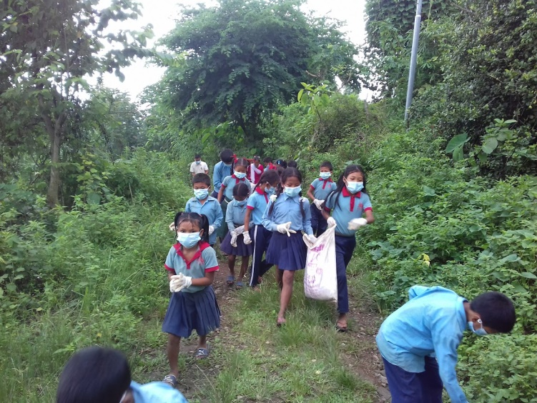
Litter picking event in Charghare
10. Facilitation for coffee parchment preparation and selling
The communities of Lahape, Baseni, Ripaha, Pokhari, Charghare and Dhoubadi had collected cherries and produced some coffee parchment from previous years in traditional method. They had no idea of market available to sell their small scale coffee production. They used this parchment for their domestic consumption purpose and the rest went to waste. Keeping this in mind, the project organized coffee cultivation & processing training in all these sites. Through the project, we provided coffee pulper machine, made regular follow-ups, did coaching & feedback for coffee cherry picking, pulping to prepare coffee parchment. After getting the pulper machine, regular feedback, & follow-up they started fresh cherry pulping. Now they have started to make coffee parchment as much as possible. The farmers of Lahape, Baseni & Ripaha had sold 76.5 kg parchment last year. After the training & follow-up the numbers of domestic coffee users' farmers, production of coffee parchment have increased. They have sold 152 KG coffee parchment this year at the rate of Rs. 400/KG. After getting income from coffee parchments, farmers are encouraged for coffee seedling plantation now. Below is the details of coffee parchment sold this year:

Project site | Parchment preparing HHs | Sold parchment in KG
Lahape | 8 | 105
Baseni | 6 | 25
Ripaha | 3 | 8
Dhoubadi | 6 | 12
Pokhari | 1 | 3
Charghare | 1 | 2
Total | 25 | 152
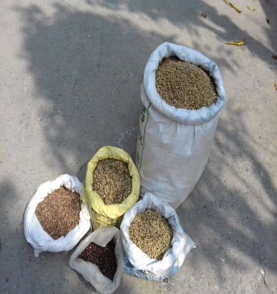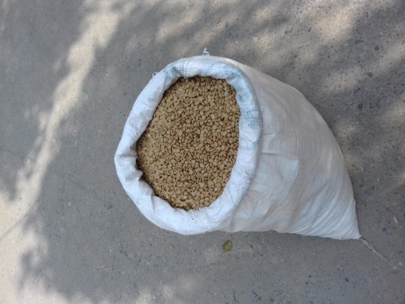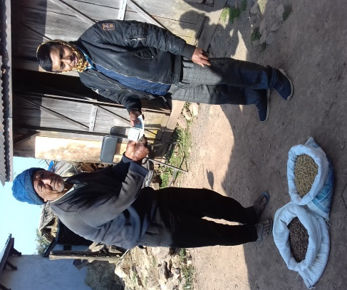
Coffee parchments ready for sale & sold at doorstep
11. Monitoring & coaching of coffee seedling nurseries.
We had conducted coffee cultivation training of project sites Lahape, Baseni, Ripaha, Pokhari, Charghare and Dhoubadi. As a product of this training a coffee seedling nursery had been established in each site. During this period we have regularly visited, monitored, and advised feedback to the communities for betterment of coffee nurseries. Nurseries of all sites are growing well. There are more than 2000 coffee seedling in each six nurseries. Seedlings are being cared well by farmers' group members. The entire 12 thousand seedlings will be used for transplant in the project area next year.
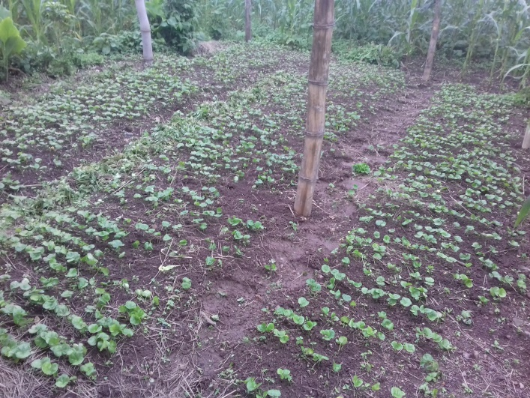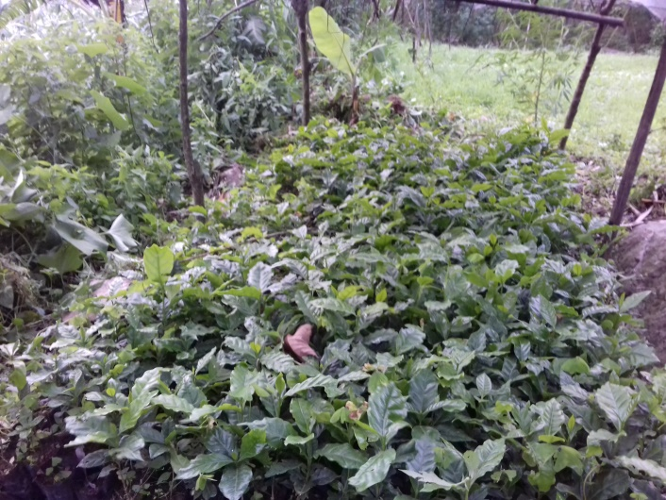
Coffee Nursery of Dhoubadi & Lahape

Challenges faced
To hire OJT volunteers: Most of the Municipality/Rural municipality & registered agriculture form have provision to mobilize OJT volunteers with certain benefits and they do have scope & option for OJT volunteers. But we do not have much benefits available to them. They opt for more beneficial and easier areas to work in. The OJT volunteers did not want to go in our remote project sites this year due to lack of financial support for them and areas are too hard to access.
Decrease of coffee plantation site by growing trend of soil erosion & landslide: Many farmers of Ripaha were interested in coffee plantation. But a huge land slide had destroyed most of the farmers' fertile arable land last year. Due to this, they had to shift to upper land for cereal crops cultivation where they had planned to plant coffee seedlings. This made them give up on the idea of coffee plantation as we expected.
Matching support from other stakeholders: Municipalities contribute 75% in agriculture support to the registered individual agricultural firm, while our project contributes only 50% for this activity. So, most of the farmers more encouraged to obtain it from Municipality support rather than from our project support. We need to focus our effort in those people who cannot even register their firms in the Municipality. This needs revision.

A Case study
Mr Rajali is on the way to be a successful coffee farmer
Tulasi Rajali Magar-53 is a resident of Hupsekot 5 Baseni and lives in ten membered family (4 F & 6 M). Agriculture is the major occupation for his family survival. Traditionally he has been cultivating maize, millet, ginger and some paddy as major crops. For additional income he works on daily wages & goat keeping for his family livelihood. He has 2 coffee plants giving fruits. Though it has given coffee beans but Tulasi has not properly managed or cared for them due to lack of knowledge of coffee cultivation and its uses.
As the Layer Farming for Adaptation (LFAP) project begun in his village, he got involved as a group member of farmers and got opportunities to become involved in famers group meetings, onsite technical support, coffee cultivation training, seed and sapling support. After being supported and having regular encouragement he started to manage his existing coffee trees. After the coffee training last year, he planted 415 coffee plants in his land. The matured coffee plants are now managed by thinning, pruning, watering and managing. After proper care of the plants, Tulasi reaped 4 KGs of coffee parchment from these two trees. He sold the parchment in Rs 400.0 per KG and earned Rs. 1600 the first ever since they were planted.
He has also other agriculture business. Tulasi grows tomato & potato. Last year he sold Ten quintals of potato in Rs 30.0 / KG and 200 kg tomato in Rs 50. KG and made Rs. 40000 from his farming. Mr. Tulasi is keeping 45 Goats that gives him some Rs 150,000 annually. Seeing the cash income and good growth of the previous plantation, he has planted 250 more coffee plants this year as well and that totals 665 coffee plants in his field. The coffee trees starts yielding coffee in four years and a tree gives a minimum of 2 KG parchment in a season. Thus he is very excited in his coffee production plantation as some of the plants have started giving fruits. As per the project suggestion he is trying to choose the fodder grass trees as shade crops. This will help him for goat raising at the same time for feeding. At the same time goat dung manure will be used as organic manure for coffee plant and other crops that gives him additional income. So, Tulasi responds; "I am following your guidance and want to be a successful coffee farmer soon, the project should support me for that"

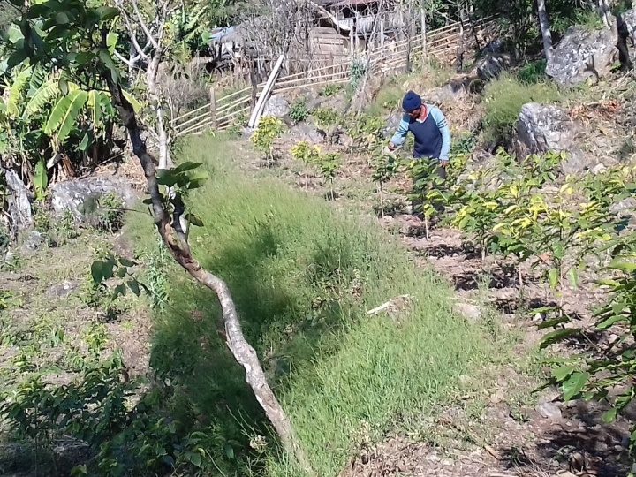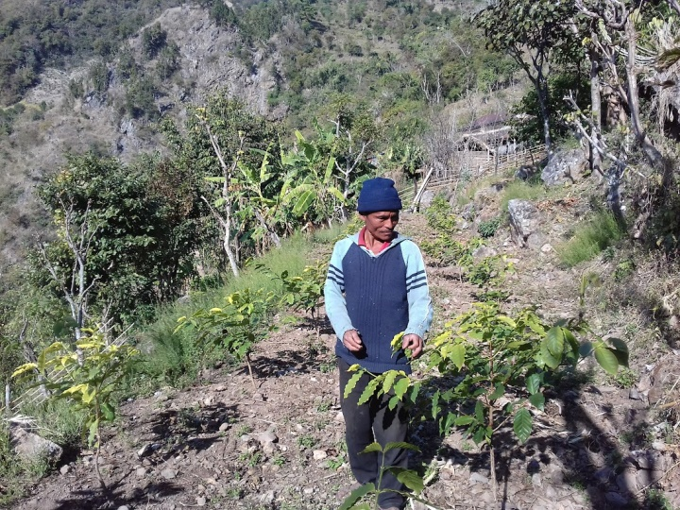
Mr. Tulasi monitoring his own coffee garden
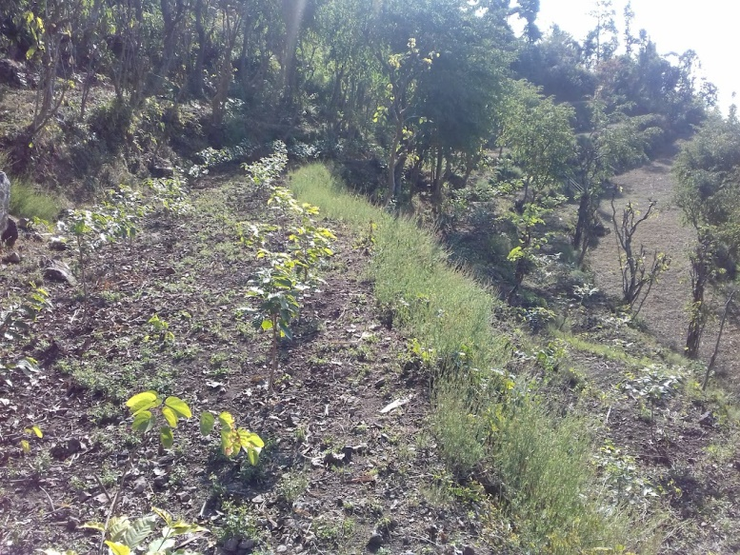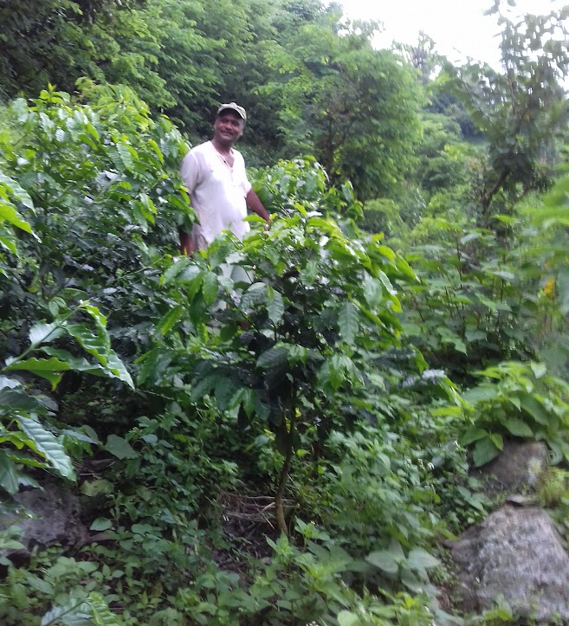
Coffee plants 2 years ago (L) and now in Tulasi's farm

